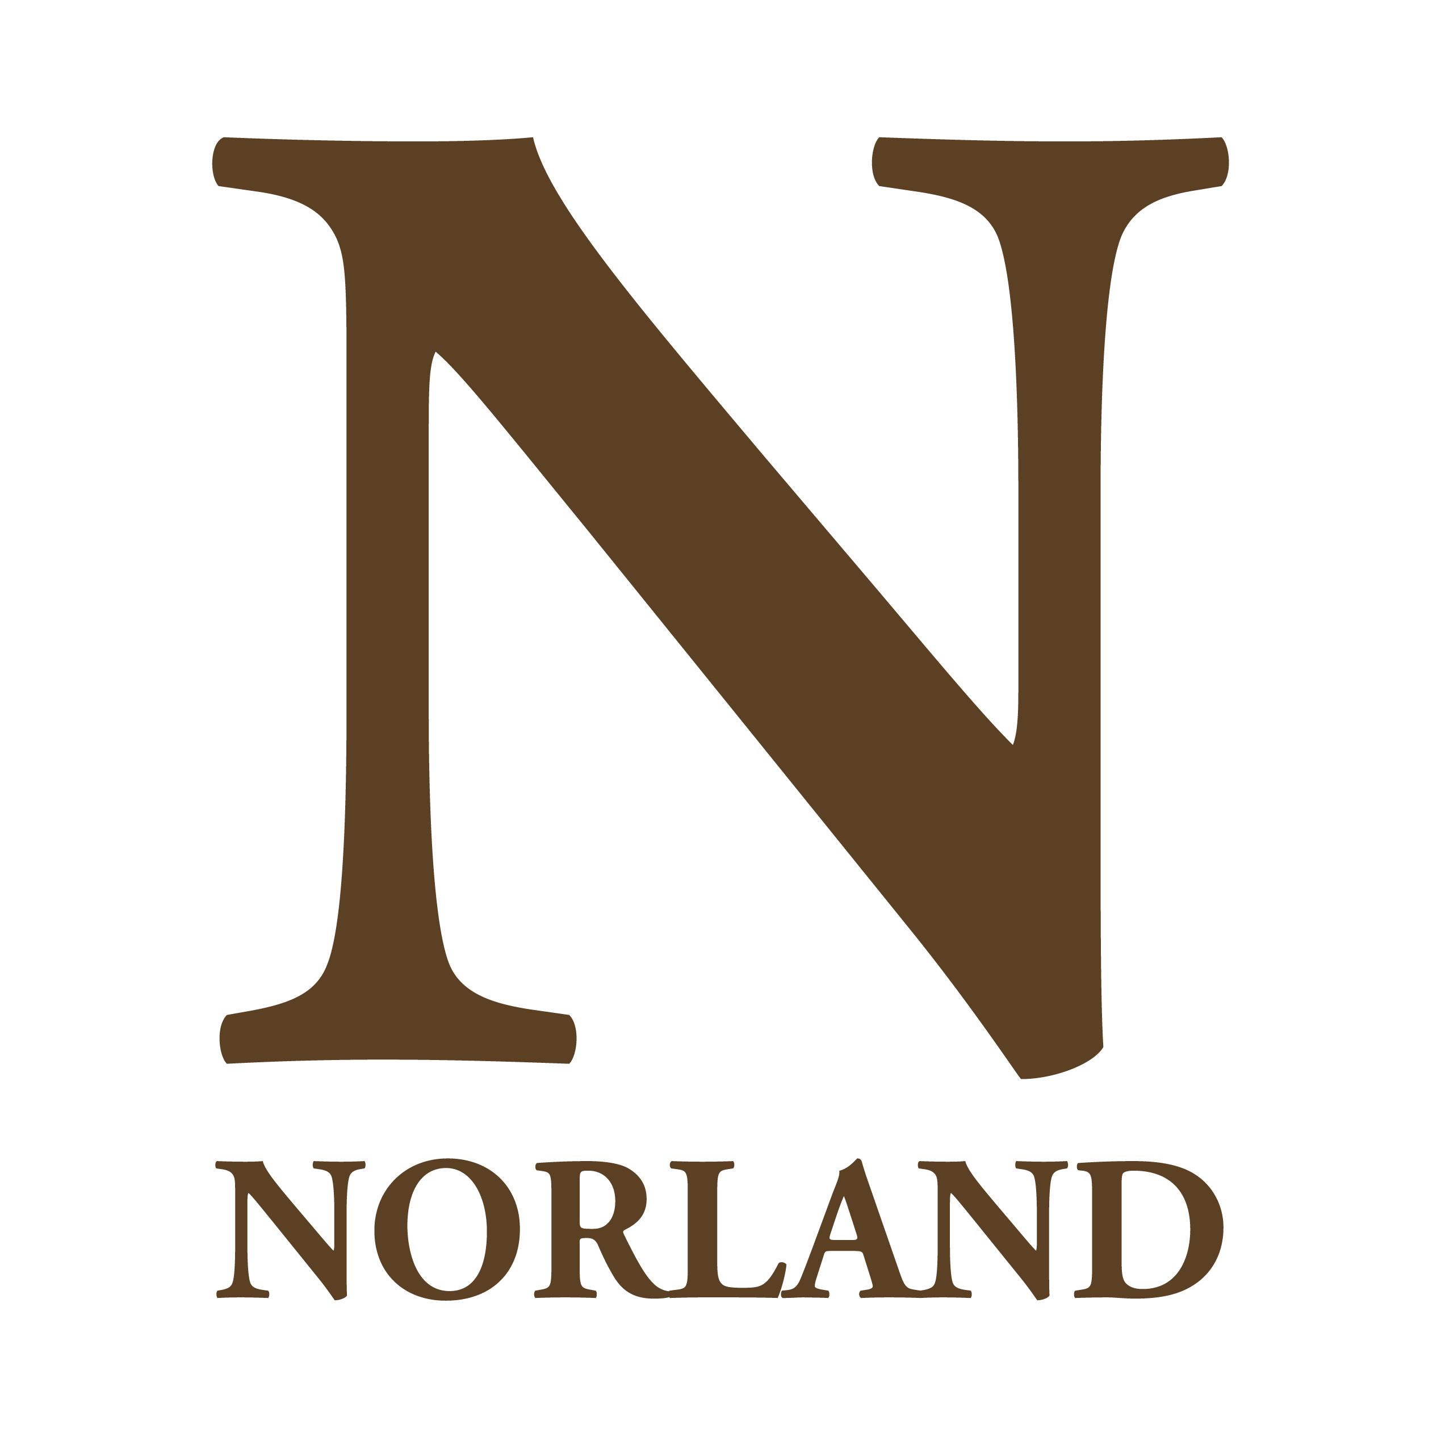
Terms and conditions - Bank Receptionist/ Administrator

Conditions of service
Full details of conditions of employment will be set out in a Limited Duration Engagement Scheme contract and the Staff Handbook which incorporates the Terms and Conditions of Employment and will be issued on appointment.

Offers of employment
Norland is committed to safeguarding and ensuring the welfare of children, young people and vulnerable adults. We expect all students and staff to share this commitment.

The suitability of all prospective staff will be assessed during the recruitment process in line with this commitment. All offers made will be on the condition of relevant safer recruitment checks being conducted and in line with the college policies and procedures.

This offer of employment is subject to proven eligibility to work in the UK, satisfactory clearance from the Disclosure and Barring Service (DBS), verified references and qualifications.

Remuneration
Hourly rate - £10.42 per hour
Salaries are paid on the last Friday of each month comprising the salary for the whole month.

Working hours
Due to the nature of the limited engagement scheme, the working hours will be ad hoc but will not be more than 35 hours per week when required. Hours of work will be specified in the Offer of a Limited Duration Engagement document.

Annual leave
The holiday year runs from 1 September - 31 August each year. Present annual leave entitlement (excluding Public Holidays) is 30 working days per year.

The holiday year runs between 1 September and 31 August. As there are no set hours for this post, it is impractical to provide your holiday entitlement in the normal way. In accordance with the published advice of ACAS, holiday entitlement is therefore calculated and paid in respect of each month worked.

The normal full-time annual leave provision is 7.6 weeks which equates to 38 working days (including 8 Public
Bank Holidays).

Norland’s stakeholder pension scheme
All eligible non-teaching staff will be auto enrolled into Norland’s Stakeholder Pension Scheme.

Flexibility
As a condition of employment, the post holder may be required to undertake such other duties as may reasonably be required, in addition to the major tasks outlined in the job description.

Smoking and vaping policy
Norland operates a strict no smoking or vaping policy.

Equal opportunities
Norland is committed to the promotion of equal opportunities and is dedicated to pursuing non-discriminatory policies and practices and to eliminate unfair discrimination on any basis. This means that we are striving to ensure that no job applicant will receive less favourable treatment than another on grounds of gender, marital status, racial origin, disability, sexual orientation or political or religious beliefs.

